**CSE 215L: Programming language II Lab**

**Faculty: Dr. Ziaul Hossain (ZHo)**

**Sec: 06**

**Lab - 02 [Control Statements-01], Spring-2021**

**Lab Instructor: Salsavil Kayyum**



**Objective:**

* To learn to use Conditional Statements
* To learn about different types of loops (for, while, do-while)
* To​ learn about two keywords such as break, continue, and their usages

|  |  |
| --- | --- |
| ***if-else*** | ***switch*** |
|  |  |
| **if(condition){** | **switch(case){** |
| **// do something** | **case 1:** |
| **}** | **// do things for case 1** |
| **else{** | **break;** |
| **// do something else** | **case 2:** |
| **}** | **// do things for case 2** |
|  | **break;** |
|  | **default:** |
|  | **// do things for default case** |
|  | **}** |
|  |  |
| ***for*** | ***while*** |
|  |  |
| **for(int i = 0; i < 10; i++){** | **while(condition){** |
| **// do something** | **// do something** |
| **}** | **}** |
|  |  |

**Tasks:**

1. Write a program that will read N numbers using a ​**while-loop** and will display their sum. N will be input to your program.
2. Write a program that takes an arithmetic operator ('+', '-', '*' or '/') and two operands as input and performs the corresponding arithmetic operation on the operands. You must use a **switch-case** to solve the problem.

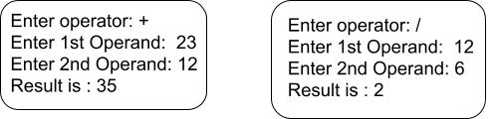

3. Write a program that prints the following pattern.

*

+++

*****

+++++++

*********

1. Write a program to find the roots of a quadratic equation.

For the values of x which are the solutions of the equation are given by:

